**How can find Friday Log Server Script**

Log Server IP :- **192.168.1.19**

Username :- h8aaa

Password :- h8aaa

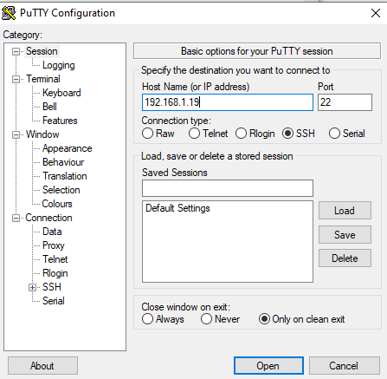

**Now Type Command:-**

* **sudo -i (then enter and type password h8aaa)**
* **Password :- h8aaa**

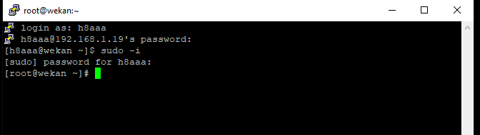

* **cd /root/dip_test/ (Type this cmd for add)**

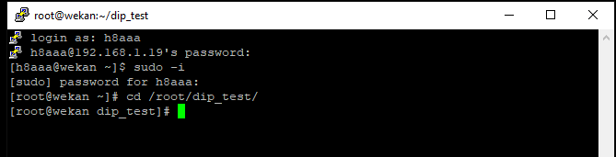

**> ls ( type ls show all file)**

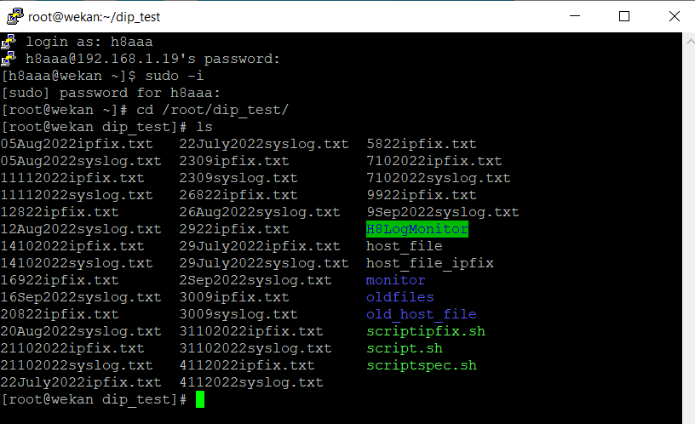

* **Then Run Below script:-**

**For Syslog :-**

**pssh -O StrictHostKeyChecking=no -A -i -h host_file_new -l $user -I<./script_new.sh > 03112023syslog.txt**

**I0g$k$3 (typepass then enter and wait few minute generating file)**

**For IPFIX :-**

**pssh -O StrictHostKeyChecking=no -A -i -h host_file_ipfix_new -l $user -I<./scriptipfix_new.sh > 03112023ipfix.txt**

**I0g$k$3 (type pass then enter and wait few minute generating file)**

* **After Generate file download from WINSCP Tool**